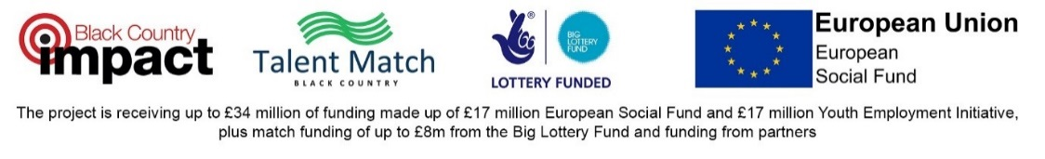

January 2018

Dear Applicant

Compliance Officer - 2 posts

Thank you for your enquiry regarding the above post. I enclose the following:
- Job description with person specification
- Application form
- Guidelines on completing the application form
- Recruitment monitoring form

The closing date for applications is Thursday 14th February 2019 at 12noon.

Please note applications received after the deadline will not be considered for shortlisting.

Application forms can be returned by email to: Recruitment@wolverhamptonvsc.org.uk or in the post to Kath Pye, WVSC 16 Temple Street Wolverhampton WV2 4AN.

Interviews will take place week commencing 25th February 2019.

If you have not been contacted regarding your application by the end of February 2019 please presume your application has unsuccessful on this occasion.

If you have any specific accessibility needs during the recruitment process please contact Kath Pye on 01902 773761 or email KPye@wolverhamptonvsc.org.uk .

We are not able to acknowledge receipt of or provide feedback about application forms, but we would like to take this opportunity to thank you for your interest in Talent Match.

Yours sincerely

Kim Babb
Talent Match Project Manager

Registered Charity
No. 700910
Company Ltd by Guarantee
No. 2288239

